FACE MASK DETECTION

Artificial Intelligence

Project Proposal 2021



Group Members: Class ID: 106266

Sahil Nenwani 9870

Hassan Noor 9827

Introduction: In this project we wanted to create face mask recognition system. IT is Artificial Intelligence base project and work to find whether any one wearing a mask or not.

Description:

We making a project that detects that some has wear a mask or not?

What is Face Mask Detection?

In the covid-19 condition it is important to wear a mask so this project made to basically help the Government officials to insure that people are following the sops.

GitHub Picture

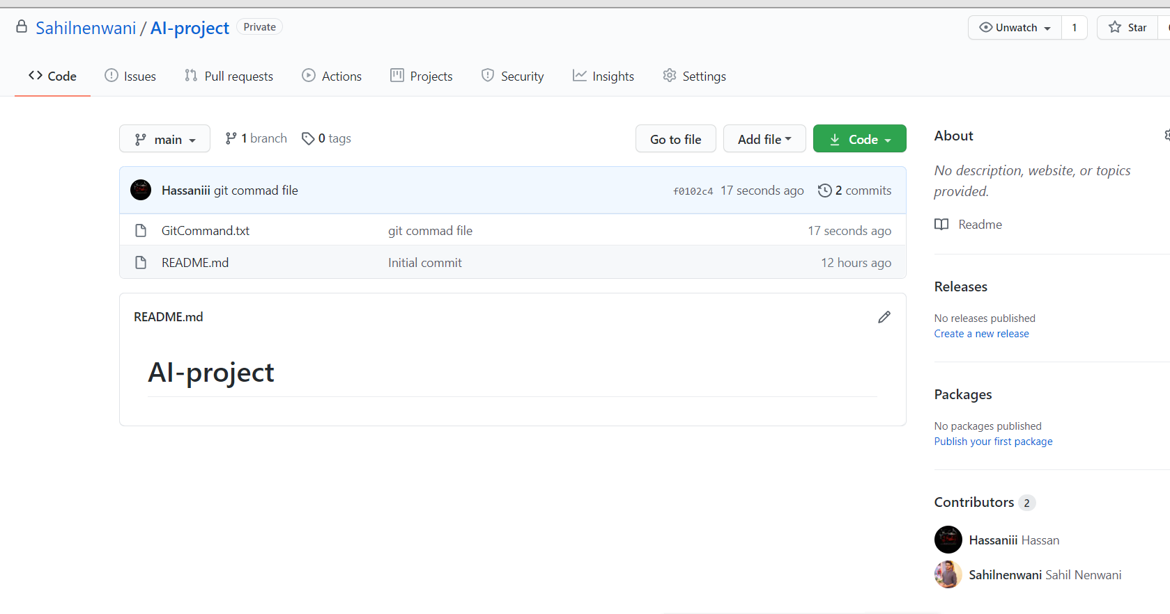

Project Planning

We are working on that it will be ready as soon as possible.

Software Requirements

* Version Control Git and GitHub
* Keras
* Tensorflow
* MobileNet
* OpenCV

**Code Language:**

We use python for this project